

**Lesson 3.1 Rules of Ultimate Frisbee**

**Demographic of Lesson**

|  |  |  |  |
| --- | --- | --- | --- |
| **Year Level:** | **9** | **Length of lesson in minutes:** | **60** |
| **Topic/Theme:** | **Ultimate Frisbee** | | |
| **Curriculum Learning Area:** | **Health and Physical Education** | | |
| **Strand:** | **Understanding Movement** | | |
| **Content Descriptor and Code:** | **Develop, implement and evaluate movement concepts and strategies for successful outcomes with and without equipment** [(ACPMP101 - Scootle )](http://www.scootle.edu.au/ec/search?accContentId=ACPMP101) | | |
| **General Capabilities:** | **Games and Sport**  modified games  non-traditional games and sports  **Challenge and Adventure Activities**  movement challenges (as individuals and in teams or groups)  **Life Long Physical Activities**  individual and group fitness activities  active recreation activities  **Critical and Creative Thinking capability**  Analysing, synthesising and evaluating reasoning and procedures  Transfer knowledge into new contexts  Identify and clarify information and ideas | | |
| **Learning Intention (objective)** | **Students are learning:** the rules of ultimate frisbee | | |
| **Success Criteria (assessment):** | **Students will be able to:**   * Demonstrate their understanding of the rules of Ultimate Frisbee. | | |

**Lesson Sequence:**

|  |  |  |  |
| --- | --- | --- | --- |
| **Timings:** | **Teacher Activity:** | **Student Activity:** | **Resources/Notes** |
|  | **Preliminaries:** | |  |
| 10min | Welcome, roll call, injury check, equipment/uniform check.  Introduce Warm-up activity | Warm-up activity  Maximal distance throw competition individually.  Divide the group into 2 even teams and conduct a maximal team throw competition.  Then conduct accuracy competition. Students aim for a target at a set distance. | Field is to already be set up with minimum 8 cones or utilising soccer field lines.  Bibs required for one team. |
|  | **Introduction (Beginning):** | |  |
| Max 5 min | Introduce the rules of Ultimate Frisbee. Reinforce no contact is allowed. | Students will divide into their teams and assemble at their end goal. |  |
|  | **Lesson Body (Middle)** | |  |
| 15 min | Teacher will act as referee, unless a student is unable to participate. In this case, the student will act as the referee to aid their learning of the rules and include their participation.  Teacher is also to observe substitutions | Students are to self-rotate substitutions. All students are to participate; the teacher is to ensure this occurs. There should be no more than 8 players on the field per team, allowing up to 2 substitutes. | Students that are unable to play can either assist refereeing or video play for later review. |
|  | **Lesson Body (Middle)** | |  |
| 15 min | Introduction of modified rules. Options:   1. 1-2 players, on each team, are given different coloured bibs for identification. The frisbee must be passed to the bibbed players between each pass. 2. Minimum number of passes is introduced. E.g. 5 3. Zone restrictions. Similar to Netball or Lacrosse |  |  |
|  | **Conclusion/Summary (End)** | |  |
| 15 min | Being discussion with students about the rules to confirm learning. Discuss how the modification of the rules changed the game.  Confirm whether the students enjoyed the games.  Students to complete self-reflection survey before the completion of the lesson. | Pack up equipment  Sitting as a group  Students that have recorded plays can share select clips or photos with the group.  Students complete self-assessment form. If the student did not directly participate in the activity, they are to complete the self-assessment on their peers. |  |

**Reflection/Notes:**

|  |  |
| --- | --- |
| **How do you know if the lesson went well?** | Students were able to participate in the game with little confusion.  Students enjoyed the game.  Students managed to assimilate the rule modification and continue playing without disruption. |

**Resources**

How to play Ultimate Frisbee for Beginners - <https://www.youtube.com/watch?v=YkMMqOUNyKk>

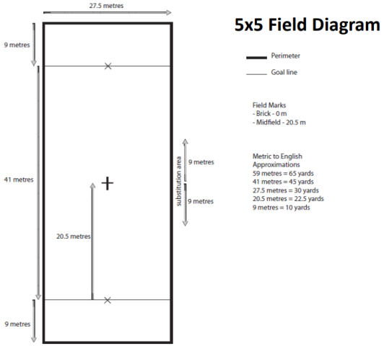

<https://detroitultimate.org/5v5-rules-outdoor>